Full-Stack AI Trip Planner

Comprehensive Project Report

# 1. INTRODUCTION

Travel is a fundamental aspect of human life, enabling exploration, cultural exchange, and personal growth. In the modern era, the travel and tourism industry has become a cornerstone of the global economy, generating trillions of dollars in revenue and supporting millions of jobs worldwide. Yet, despite the proliferation of digital tools and online resources, the process of planning a trip remains a daunting and often overwhelming task for many individuals. The digital revolution has transformed the way people approach travel planning. The internet offers an unprecedented wealth of information, from booking platforms and review sites to travel blogs and social media influencers. While this abundance of resources has made travel more accessible, it has also introduced new complexities. Travelers are now faced with the challenge of sifting through vast amounts of data, much of it unverified or biased, in order to make informed decisions. The sheer volume of options can lead to information overload, decision fatigue, and ultimately, dissatisfaction with the final itinerary. ...

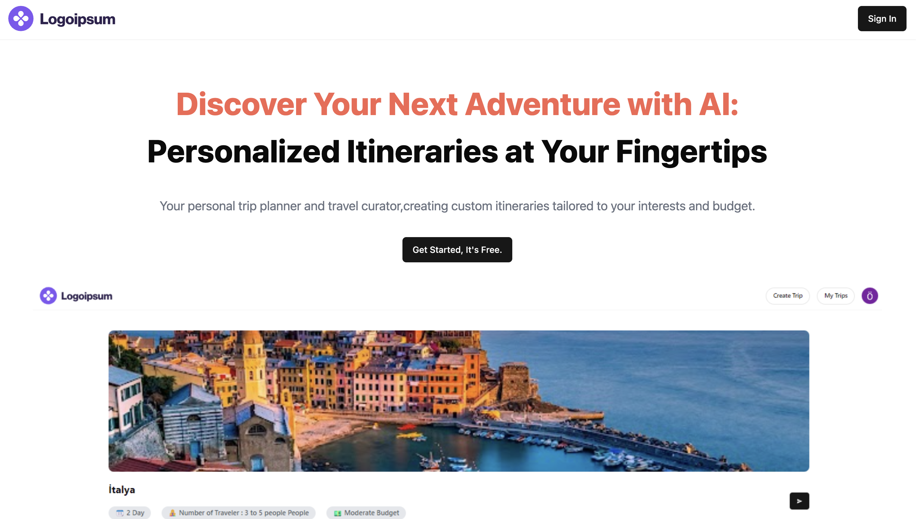

# 2. PROBLEM STATEMENT

The aim of this project is to develop an AI-powered, full-stack web application that enables users to efficiently plan, personalize, and manage their travel itineraries through a seamless, intelligent, and integrated platform. ...

# 3. LITERATURE SURVEY

This section provides a robust academic and industry context, detailing the state-of-the-art technologies and research relevant to the Full-Stack AI Trip Planner. ...

# 4. DESIGN CRITERIA

Here is an overview of the system design involved in building an AI-powered, full-stack trip planning platform: ...

# 5. METHODOLOGY

Here is an overview of how an AI-powered trip planner system operates from a product/system perspective: ...

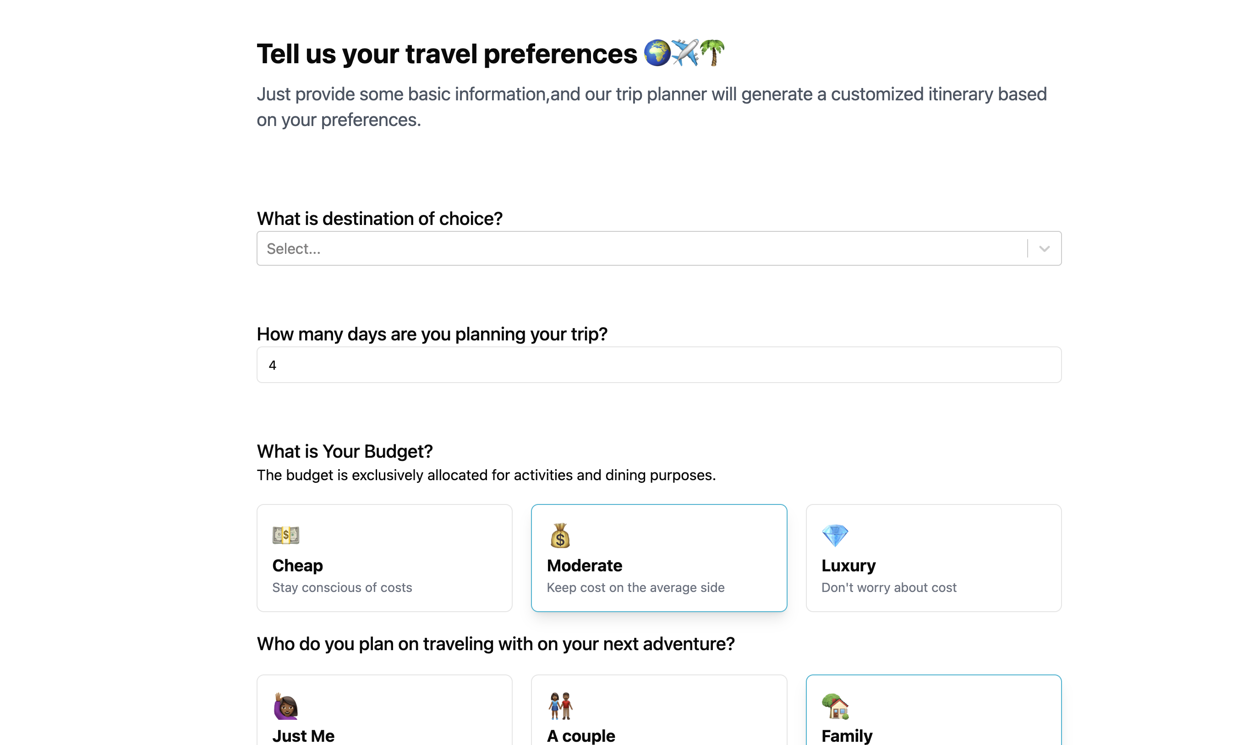

# 6. DEVELOPMENT AND IMPLEMENTATION

This section details the practical aspects of bringing the Full-Stack AI Trip Planner to life, covering the feasibility of its development, specific implementation choices, its modular structure, and the critical components that drive its functionality. ...

# 7. RESULTS AND DISCUSSION

The result of implementing an AI-powered, full-stack trip planning solution is a significant improvement in the efficiency, personalization, and overall satisfaction of the travel planning process. ...

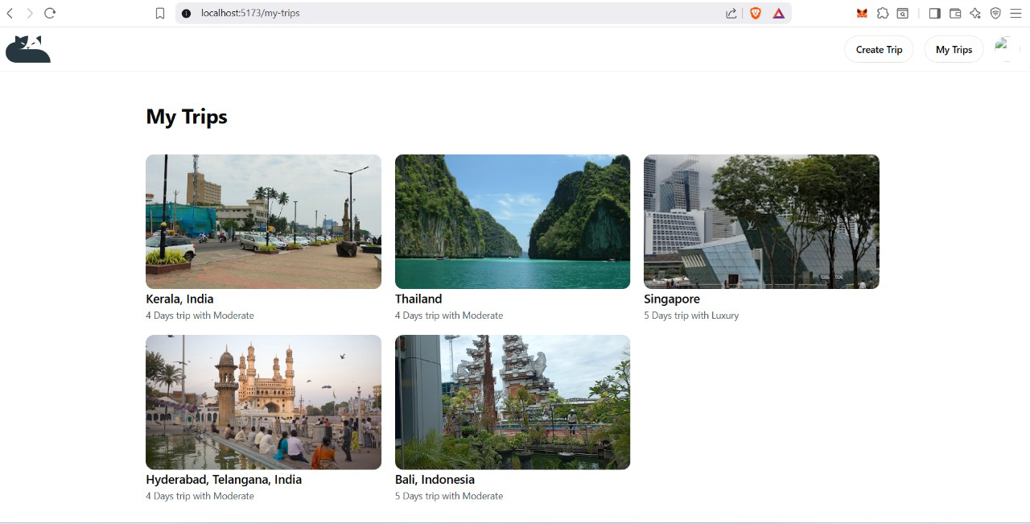

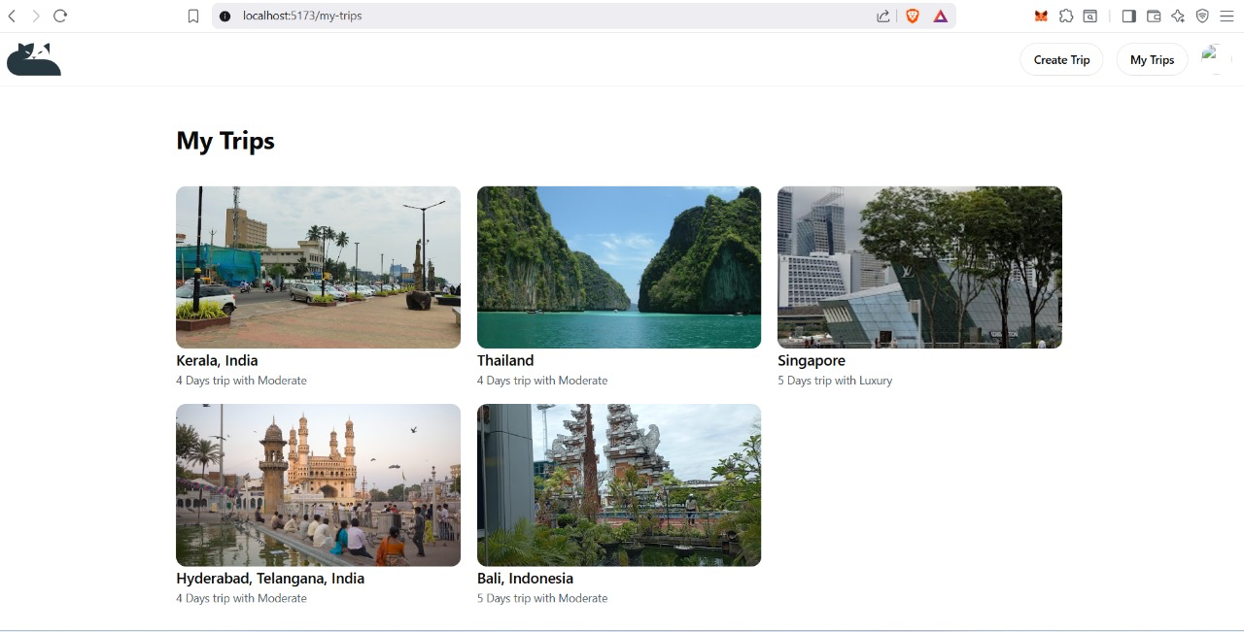

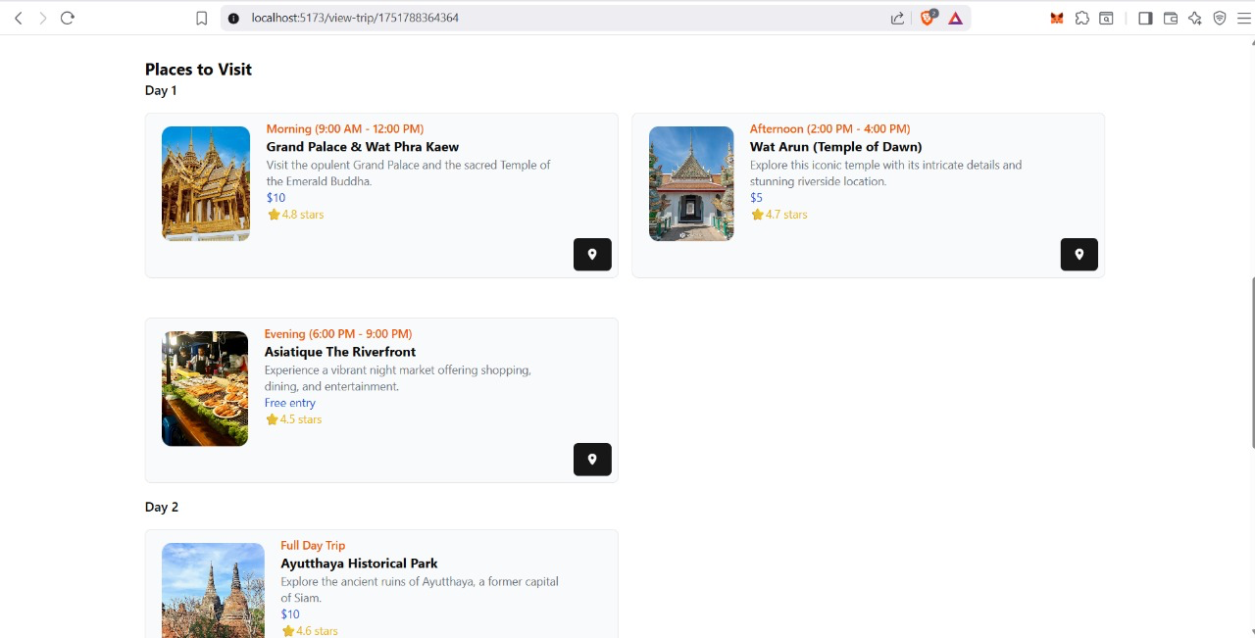

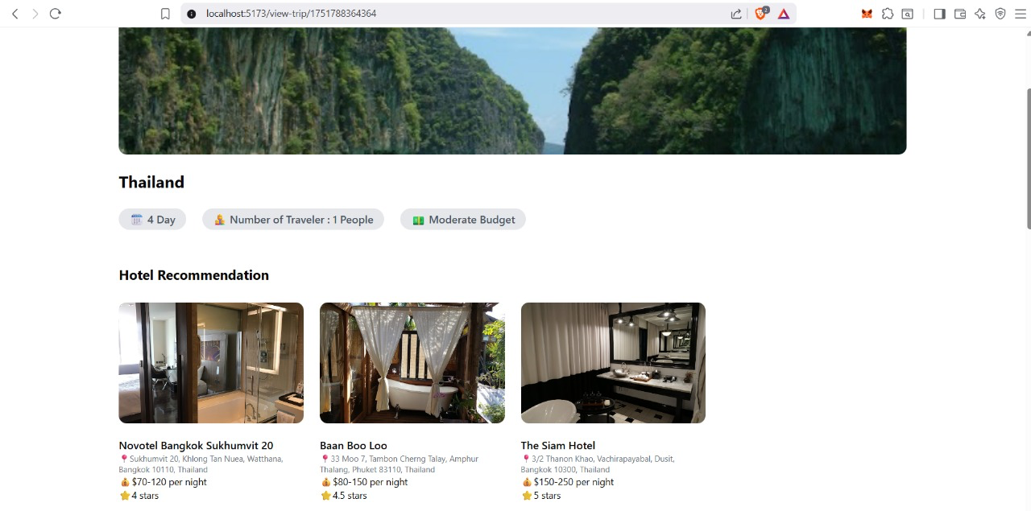

# 8. CONCLUSION AND FUTURE WORK

In conclusion, the development and implementation of the Full-Stack AI Trip Planner represent a significant advancement in the field of intelligent travel planning. ...

# 9. BIBLIOGRAPHY / REFERENCES

1. Li, X., Wang, Y., & Yu, Y. “Personalized Travel Recommendation Based on User Preferences”, IEEE Access, 2020. ...